

Rock-Paper-Scissor Game Project

Name :- Prajjwal Pandey
Reg no :- 25BAI11515
Course :- CSE1021

Introduction :-

Rock Paper Scissor Game is most popular and played game all over the world .

The objective of this project was to develop a functional, interactive, console-based implementation of this classic game, primarily to apply and demonstrate fundamental programming concepts such as conditional logic, user input handling, and random number generation.

Problem Statement :-

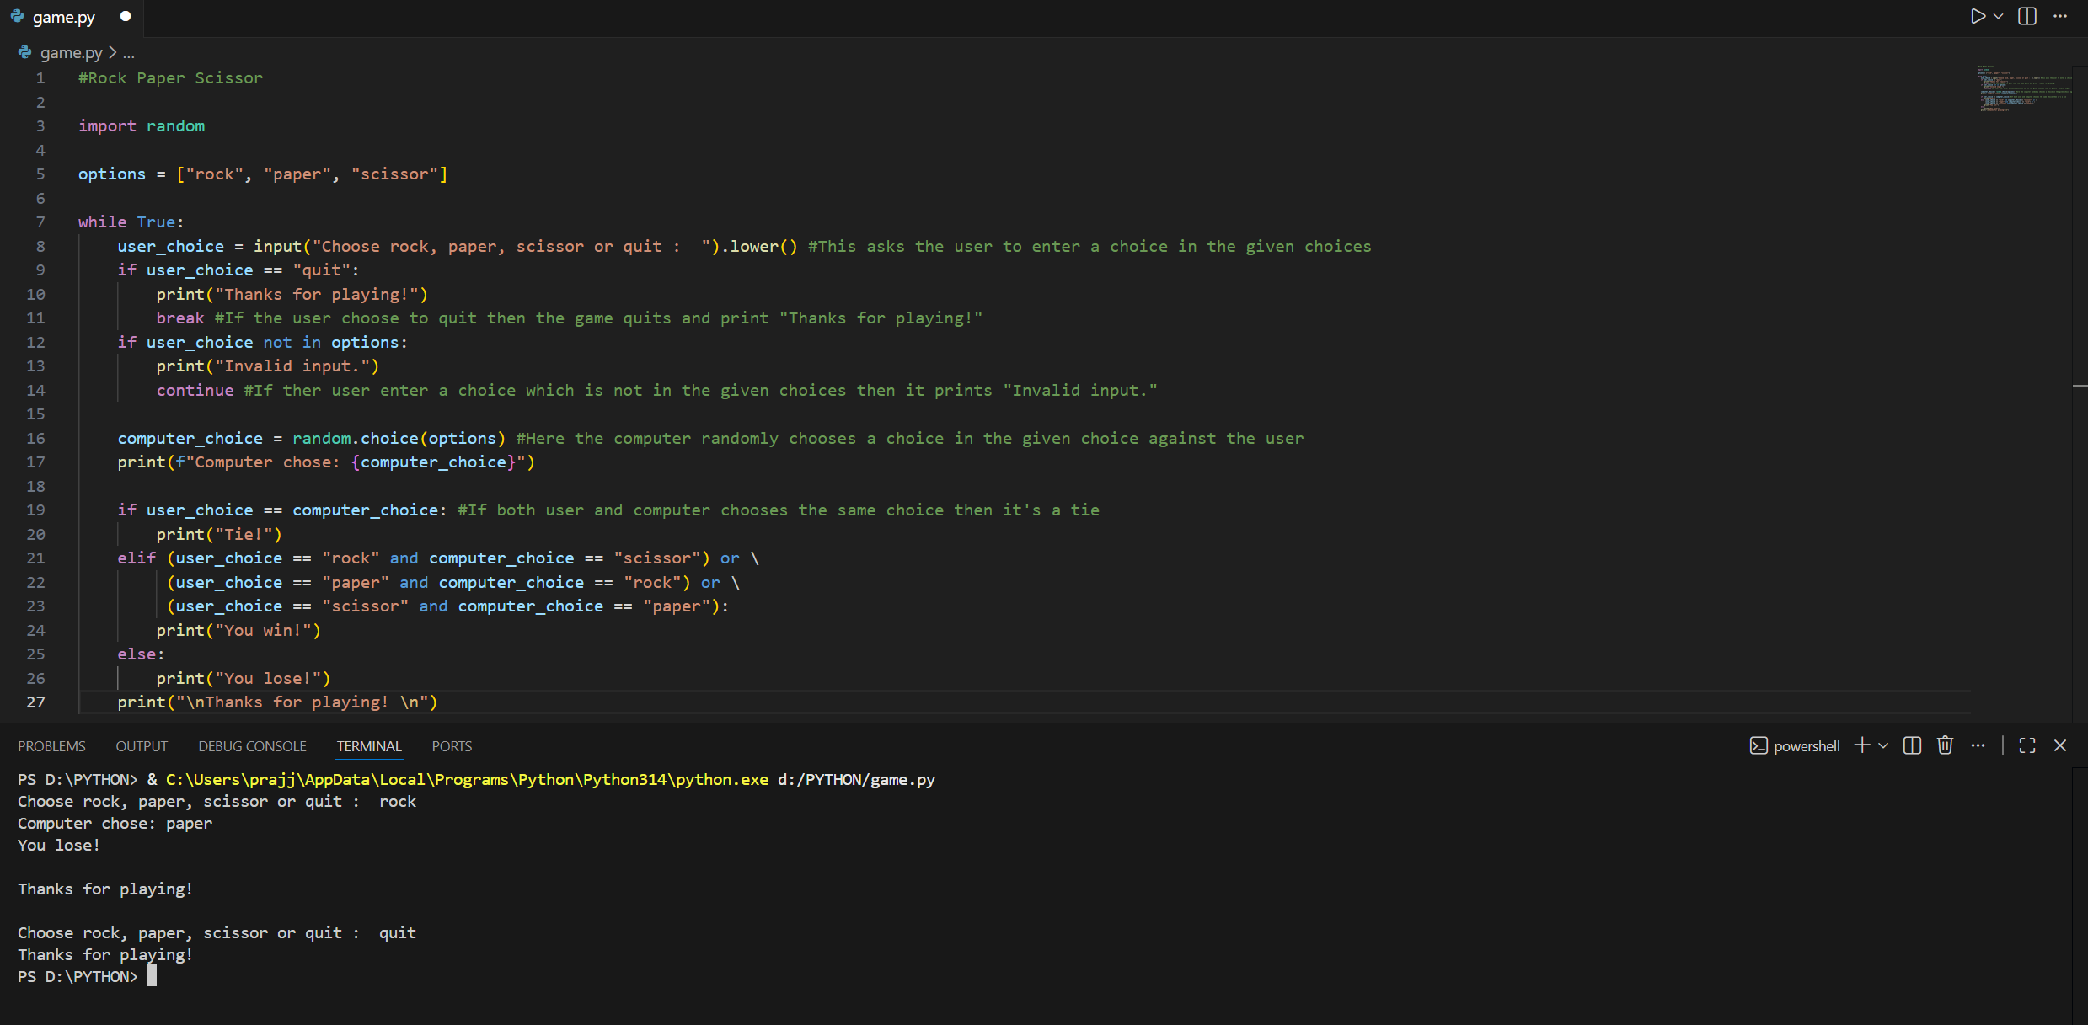

Implementation Details :-

1.Start Main Game Loop :
- Get user choice
- Get computer choice
- Determine winner
- Display results and display Thanks for playing!
- Prompt to play again
2.If Quit :
- Display Thanks for playing!

Results :-

Learning and key takeaways:-

Fundamental Programming Concepts
This project served as a hands-on exercise to solidify foundational knowledge.
- Conditional Logic and Control Flow:
  - Learning: Mastering the use of complex if, elif, and else statements to implement the win/loss/tie outcomes of the Rock-Paper-Scissor game.
  - Takeaway: Learned the importance of structured decision-making in code and how to systematically cover all logical paths in an application.
- Random Number Generation:
  - Learning: Successfully integrated the language's random module/library to ensure the computer's move was unpredictable, meeting the Reliability requirement.
  - Takeaway: Understood the necessity of randomness in simulating real-world or game scenarios and the proper use of utility libraries.
- Input/Output (I/O) Handling:
  - Learning: Implementing robust input validation loops to handle non-compliant user entries .
  - Takeaway: Recognized that user input is a primary source of errors and that defensive programming (error handling) is essential for a stable user experience.

References :-
The game is most popular in the whole world and it’s rules are also very much familiar to everyone .
In this game –
- Rock beats Scissors
- Scissors beats Paper
- Paper beats Rock

I wish my project is attractive and useful for entertaining this busy generation.

